Bug Report

Website Link :- <https://www.skywingcargopackers.in/packer-movers-hyderabad.php>

Requirement :- Testing Quick Links section as per requirement, i.e :-

* Home
* Our Services
* Contact Us
* Packers and Movers Hyderabad

1)Home –

Bug H01 (H = Home) - A typographical error is present in the text where "east" is used instead of "easy," causing confusion and affecting the clarity of the sentence.

Issue Description :

In information of ‘ CAR TRANSPORTATION’, In the sentence, "Moving car is not a east task," the word "east" is incorrectly used instead of "easy." This error may lead to confusion for readers trying to comprehend the meaning of the sentence.

Expected Result : The sentence contains a typographical error where "east" is used instead of "easy," potentially confusing readers and detracting from the overall readability of the text.

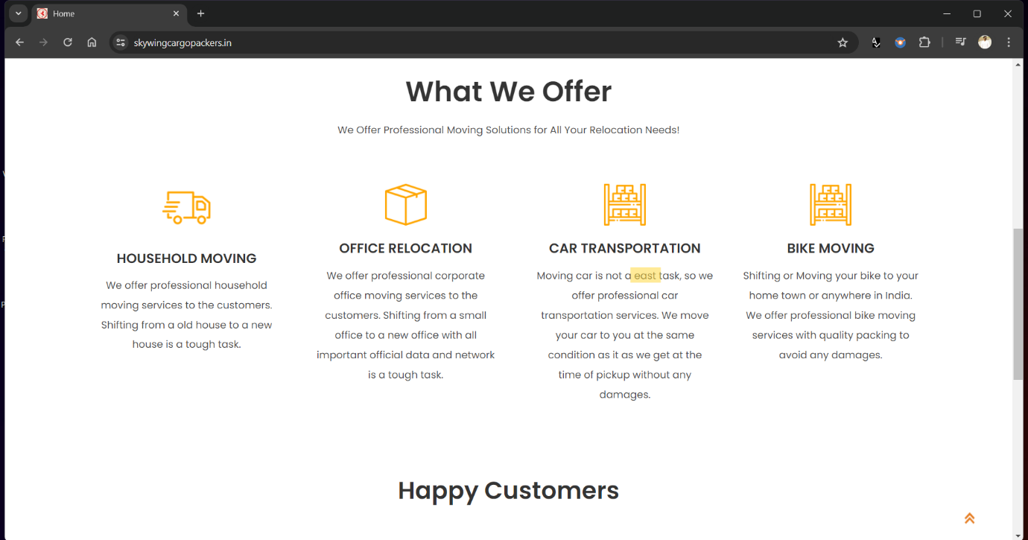

2) Our Services –

Bug OS01 – There is an inconsistency in the company name and the established date mentioned in two different sentences within the document.

Issue Description:

In the document, the company’s establish date is stated as 'Skywing Cargo since 1999 Packers & Movers Hyderabad' in one sentence, while in another sentence, it is mentioned as 'We professional company providing solutions to all moving your needs since 2005.' This creates confusion regarding the accurate company name and the year of establishment and the year 2005 is stated at every page of website at bottom.

Expected Result :

The company name and the established date should be consistent throughout the document for clarity and accuracy.

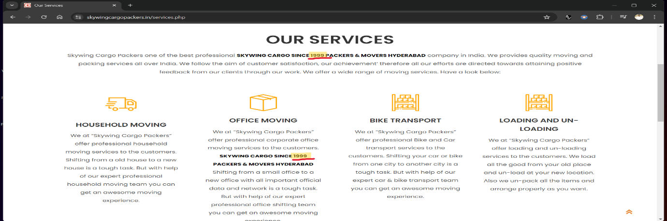

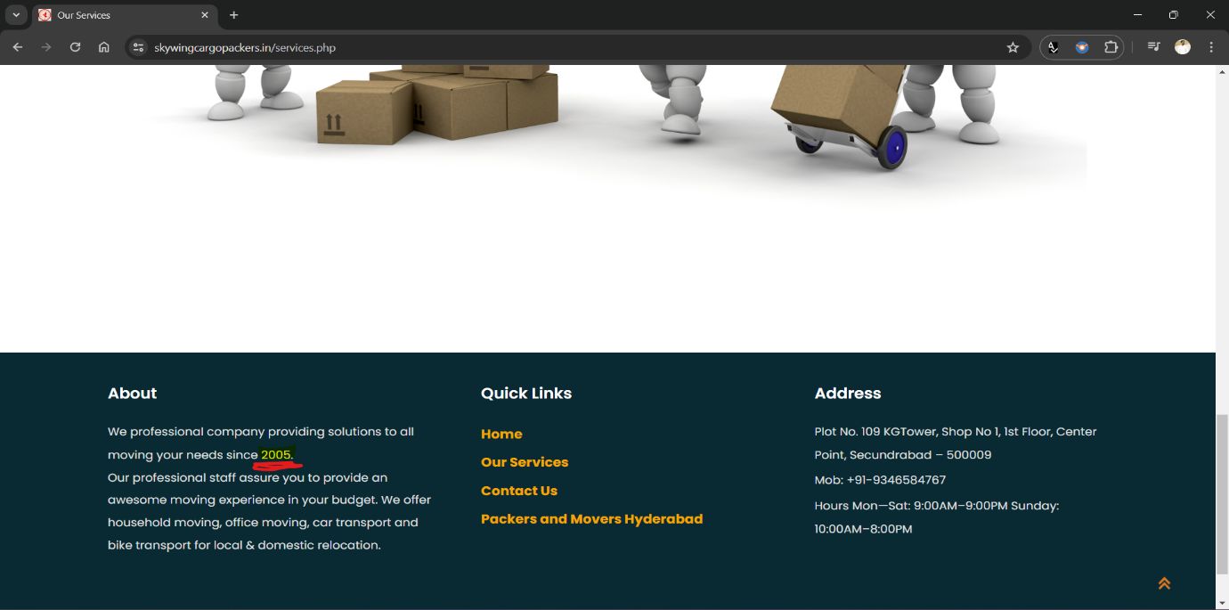

3)Contact Us-

Bug CU01 – The Contact Us button displays incorrect city names and lacks proper addresses, leading to confusion and potential inconvenience for users.

Issue Description :

In the Contact Us section, the city names listed are misspelled and do not provide proper addresses. The incorrect city names include 'Jaypur' instead of 'Jaipur,' 'Gowati' instead of 'Guwahati,' 'Aurngabad' instead of 'Aurangabad,' 'Kollketa' instead of 'Kolkata,' 'Manglore' instead of 'Mangalore,' 'Murdabad' instead of 'Moradabad,' 'Ahmdabad' instead of 'Ahmedabad,' and 'jodhapur' instead of 'Jodhpur.'

Expected Result:

The Contact Us section should display accurate city names with correct spellings and provide proper addresses for each city to assist users in locating the company's offices or branches. 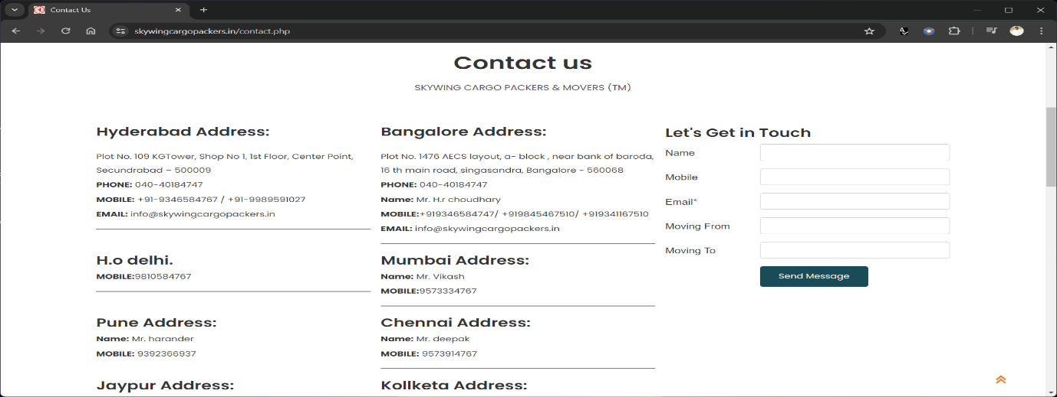

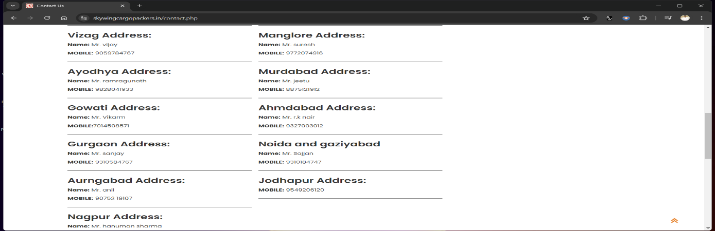

4) Packers and Movers Hyderabad-

Bug PMH01:

A grammar error is present in the text where "my" is used instead of "may," affecting the accuracy and clarity of the sentence.

Issue Description:

In the sentence, "the chances that while shifting it my damage so accordingly," the word "my" is incorrectly used instead of "may." This error alters the intended meaning of the sentence and affects its readability.

Expected Result :

The sentence should use the word "may" instead of "my" to convey the possibility of damage occurring during the shifting process, maintaining clarity and coherence.

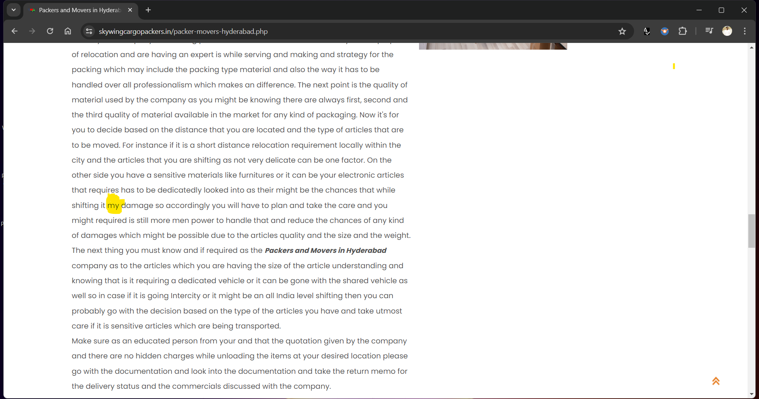

Bug PMH02:

There is a misspelling in the company name within the header section of the document, resulting in an inaccurate representation of the company's identity.

Bug Description:

In the header section of the document, the company name is misspelled as "skywing cargo packers ing cargo packers." The repetition of "cargo packers" and the inclusion of "ing" indicate a typographical error, leading to confusion regarding the correct company name.

Expected Result :

The company name should be accurately spelled and presented in the header section of the document to ensure a clear and consistent representation of the company's identity.

